COFFEE SHOP SALES ANALYSIS DASHBOARD USING POWER BI – WEEK 4

Week 4 Report: Data Storytelling and Narrative Design

Submitted By: Jonnalagadda Venkata Naga Vishnusri

Internship: Virtual Power BI Data Visualization Internship

Organization: Henry Harvin Education in collaboration with Yuva Intern

Dataset: Coffee Shop Sales Dataset (Maven Analytics)

Tools Used: Microsoft Power BI

Submission Date: 22 August 2026

Project Title: Coffee Shop Sales Analysis Dashboard using Power BI – Week 4
Table of Contents:
- Introduction
- Story Objective
- Data Storytelling Approach
- Visualization Used
- Story Mapping
- Key Business Insights
- Business Recommendations
- Conclusion

- Introduction:
The Coffee Shop Sales Analysis project focuses on presenting sales data through an interactive and easy – to – understand Power BI report. The purpose of the project is to transform raw sales information into meaningful business insights using data visualization and storytelling techniques.
The report presents overall sales performance, sales trends over time, product category performance, store – level performance, and the top products contributing to sales. Instead of presenting the data as isolated charts, the dashboard is structured as a story that guides the user from overall business performance to detailed insights.
The Power BI report uses KPI cards, a Line chart, Bar charts, and a Tree map to communicate the most important findings. The storytelling approach makes the report useful for both technical and non – technical users and supports data – driven business decisions.
- Story Objective:
The main objective of the data story is to understand the coffee shop’s sales performance and identify important trends, high-performing product categories, store locations and products.
- Data Storytelling Approach:
The story is organized in the following sequence:
Overall Performance → Sales Trend → Product Category Performance → Store Performance → Top Products → Business Insights

This structure allows the viewer to first understand the overall business position and then explore the factors contributing to sales performance.
- Visualizations Used:
- KPI Cards:
The report displays Total Sales, Total Transactions and Total Quantity to provide an immediate overview of business performance.
- Sales Trend Over Time:
A line chart is used to show how sales changed over time and to identify the overall trend and fluctuations.
- Sales by Product Category:
A bar chart compares sales across different product categories and identifies the highest performing categories.
- Sales by Store Location:
A bar chart compares sales performance across Hell’s Kitchen, Astoria, and Lower Manhattan.
- Top 10 Products by Sales:
A Tree map highlights the products contributing most to overall sales.
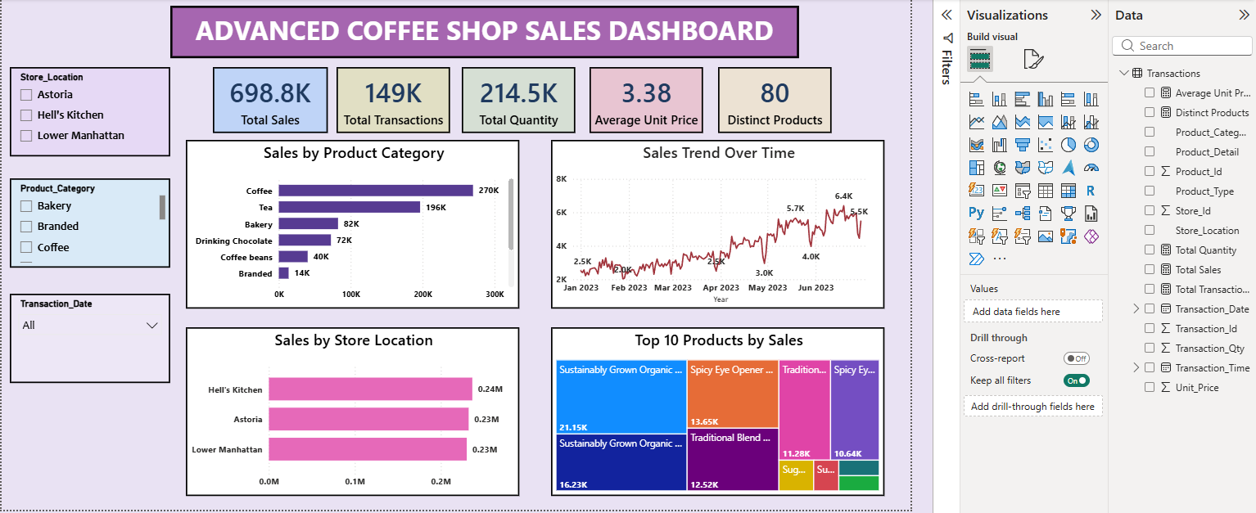
Figure 1: Advanced Coffee Shop Sales Dashboard

- Story Mapping:
- Beginning – Overall Performance:
The story begins with KPI cards showing 698.8K total sales, 149K transactions, and 214.5K total quantity.
- Middle – Trends and Drivers:
The sales trend shows an overall increasing pattern over time with some fluctuations. Product category analysis shows that Coffee and Tea are the strongest contributors to sales.
- Detailed Performance:
Store – level analysis shows that Hell’s Kitchen has slightly higher sales compared with Astoria and Lower Manhattan. The Top 10 Products visual identifies the products contributing significantly to overall sales.
- Conclusion – Business Takeaway:
The combined insights help decision – makers understand sales performance and focus on high – performing products, categories, and store locations.
- Key Business Insights:
- Total Sales are 698.8K.
- Total Transactions are 149K.
- Total Quantity is 214.5K.
- Coffee is the highest – performing product category at approximately 270K in sales.
- Tea is the second – highest category at approximately 196K.
- Sales show an overall increasing trend over the period, with some fluctuations.
- Hell’s Kitchen has slightly higher sales than Astoria and Lower Manhattan.
- The Top 10 Products’ view helps identify major contributors to overall sales.

- Business Recommendations:
Based on the visual analysis, decision-makers can focus on high – performing categories such as Coffee and Tea. The top – selling products can be monitored to understand customer preferences and maintain their availability.

Store – level performance can also be reviewed regularly to identify differences between locations. The sales trend can be monitored over time to identify periods of growth and fluctuations. These insights can support better product planning and store – level strategies.

- Conclusion:
The Coffee Shop Sales Analysis demonstrates how Power BI can be used to create an effective data – driven story. By combining KPI cards, time – based analysis, product category comparisons, store performance analysis, and a Top 10 Products view, the report presents complex sales information in a clear and structured manner.

The storytelling approach helps users move overall performance to detailed business insights. The report demonstrates the importance of selecting appropriate visualizations and arranging them in a logical sequence to communicate data effectively. Overall, the Power BI report clearly supports sales analysis and data – driven decisions.

